**Dual Energy CT**

# Introduction

The purpose of this project is to explore dual-energy CT. Light of different wavelengths (i.e. energies) is used to scan colored objects in a phantom.

In this project, we will use a dual-energy CT, which includes materials of three different colors. phantom Please see **Fig. 2**, there are red, green, and black objects. We will calculate the SNR (Signal-to-Noise Ratio) and CNR (Contrast-to-Noise Ratio) for an ROI (Region of Interest) within those objects.

Dual Energy CT and spectral imaging are used to better discriminate structures and objects according to their absorption characteristics at various imaging energies.

Linear attenuation coefficients of tissues are functions of photon energy. This energy dependence varies for different materials and tissues. In DECT, two different energy spectra (colors) of X-ray photons are used to image an object. Analyzing the attenuation coefficient values obtained at each spectrum provides information that may improve the identification of the materials within the object being scanned. This principle is similarly applied in this duel-energy optical CT imaging experiment. In the DeskCAT™ scanner, Dual Energy is performed using different light wavelengths (green and red light see **Fig 1**.). This is illustrated as follows.

|  |
| --- |
| D:\文档\WeChat Files\wxid_pbsa8aeo33m222\FileStorage\Temp\5a890d8866d59d8de8e7b2e5e9a11ca.png |
| ***Fig 1.*** *Dual Energy DeskCAT™ scanner schematic* |

# EXPERIMENT

## Materials

* DECT phantom (**Fig 2**)
* 2L water
* DeskCAT Multi-slice Optical CT Scanner

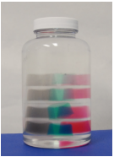

***Fig 2.*** *DECT phantom*.

## Experimental Procedure

1. Select the Red LED lights or Green LED lights as your light source using the **Wavelength Selection Switch (Fig 3)**.

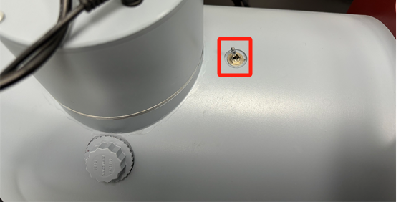

***Fig 3.*** *Wavelength selection switch*

1. Adjust the camera setting to 50% of maximum brightness (reducing the brightness allows for evenly distributed noise) by selecting **Scanner -> Camera Settings (Fig 4)**.

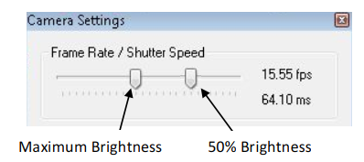

***Fig 4.*** *Camera setup diagram*

1. Under **Calibration $→$ Geometry Calibration**, select Auto-Cal and accept the values. Calibration must be done with NO phantom loaded.
2. Set the Number of projections on the side panel to acquire data.
3. Do not place phantom $→$ click on the left sidebar to **scan reference data**.
4. **Load the DECT Phantom** into the scanner by attaching the phantom to the Rotary Stage using the Jar Clamp and mounting the Rotary Stage onto the scanner. Acquire a Data Scan using the Start Data Scan button on the Side Panel. Wait for the scan to complete.
5. Under Reconstruction $→$ Reconstruction Options, select **Hamming Filter.**
6. Select the Voxel Resolution option and press Start Reconstruction to perform a reconstruction. Observe the reconstruction results using the software.
7. Switch the light source and repeat the steps above.

# Reconstruction

## Dataset

Based on the aforementioned data acquisition steps, we collected raw data. The contents of the 'rawdata' folder are shown in **Fig 5**. The contents of the folder are explained as follows:

* ScanData: Projection data collected after placing the phantom.
* ScanRef: Projection data collected without the phantom in place.
* Calibration.xml: Geometric parameters.
* Info.xml: Contains the number of projections in ScanData and ScanRef.

|  |
| --- |
|  |
| ***Fig 5.***  *Example of the raw data folder.* |

## Reconstruction Steps

The reconstruction process consists of two parts: the preprocessing part and the reconstruction part.

The preprocessing part should include the following steps:

* Flat field correction
* Geometric correction

Note: The offsets provided by the system often have some deviation, requiring manual adjustment to achieve the best results.

Reconstruction part: You can use the methods in the ASTRA Toolbox ([The ASTRA Toolbox — ASTRA Toolbox 2.1.0 documentation (astra-toolbox.com)](https://astra-toolbox.com/)) for reconstruction, or you can find other methods for reconstruction, such as iterative reconstruction, and deep learning reconstruction. **HOWEVER, FBP RECONSTRUCTION RESULTS MUST BE PROVIDED!**

# Analysis

**Purpose**: This project is to explore dual-energy CT. Light of different wavelengths is used to scan colored objects in a phantom.

**Task**: You need to select the appropriate regions of interest (ROIs), calculate and compare the SNR (Signal-to-Noise Ratio) and CNR (Contrast-to-Noise Ratio) of different ROIs in the reconstruction results under different wavelengths of light scanning conditions, and analyze their variations in conjunction with different scanning conditions. **Report your results in both qualitatively images as well as quantitative tables.**

# Additional Question

How does dual-energy CT do tissue decomposition? Please use your experimental results to answer this question.